|  |  |
| --- | --- |
| Indonesian Construction SOE: Riding the Wave |  |

# http://cdn.tmpo.co/data/2012/05/01/id_118050/118050_620.jpg**Analysis of PT Wijaya Karya Tbk**

In the next 5 years as underlined in Master plan for Acceleration and Expansion of Indonesia's Economic Development (MP3EI), infrastructure and economic development will become main focus of the government. In the 2015-2019 development plan, transportation infrastructure of 2650 Km of road, 1000 Km of toll road, 15 airport, 24 port, and 3258 Km of train track will be build. While in Energy Sectors, 2 refinery each with a capacity of 300 thousand barrel.

During its implementation, Construction SOE is expected to handle and cooperate with SOE dealing with the financing side. In the future Engineering Procurement Construction (EPC) is expected to give higher profit margin and SOE are encouraged to expand their business activities to include EPC

As one of the biggest Indonesian Construction SOE, PT Wijaya Karya Tbk (WIKA) is one of the leading performer both in financial term and Good Corporate Governance. WIKA is poised to reap benefit from MP3EI implementation, as it is the most ready to take on this opportunity



WIKA business activities is segmented in to these four operation:

|  |  |
| --- | --- |
| * **Infrastructure and Building (IBL)**   Civil construction services, construction of facilities and infrastructure | * Energy and Industrial Plant (EIP)   Construction services in energy and EPC, operation and maintenance of power plant |
| * **Industry (IND)**   Precast concrete products such as piles, girders, railway sleepers, steel construction, automotive spare parts, products of energy conversion and mining industries | * Realty and Property (RPO)   Landed housing, high rise apartment, building management, condotel |

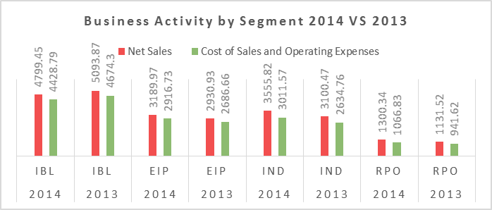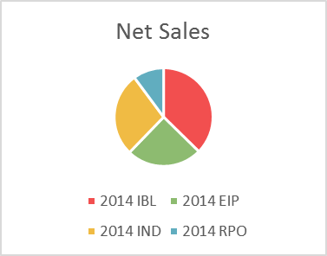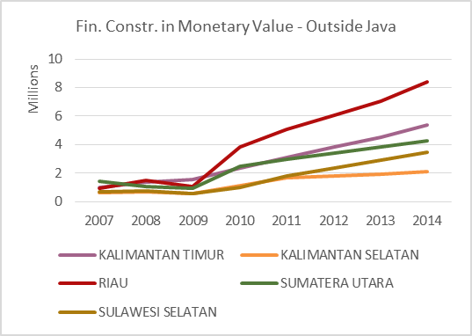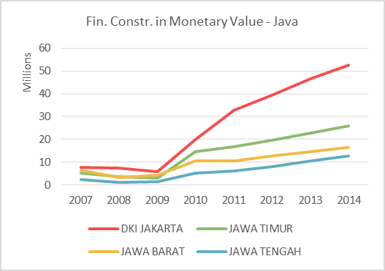

By business operation, the most lucrative segment is still IBL as it still dominate as the source of revenue. However it is also the only segment that decreased, albeit slightly as other segment (EIP,IND, and RPO) increased. However we are optimist that demand for construction is still strength both in Java and outside Java

In term of financing WIKA will also benefited from recent cut of central bank interest rate. Although empirically Indonesian bank tend to ignore signal from central bank by not decreasing their interest rate. We can expect that financing for large infrastructure project which was usually carried by syndication will get a special consideration, as they had government backing

However, currently Infrastructure building in the more remote part of Indonesia is hampered by the fact that competent worker tend to concentrate in certain region only

Funding from bank to construction sector is also still very low compared to other sector. However, there are other source of fund from foreign direct investment (FDI)

However we are still in the opinion that WIKA will thrive when compared to similar SOE like WSKT and ADHI, WIKA yield better ROE and ROA, it is only beaten in ROE by PTPP, which specializes in building housing.

 WIKA cash flow shows a sudden hike in 2014 from investment activity and decreases from operating activity, in a common business this will be interpreted negatively, but in construction industry we need to see whether there’s a new project recently started. In 2014. WIKA had finished several project which see their sudden drop in AR Turnover. Their superiority is more apparent when we put ADHI and WSKT as comparison

|  |  |  |  |
| --- | --- | --- | --- |
|  | 2014 | | |
|  | WIKA | WSKT | ADHI |
| Current Assets | 9514.4 | 10524.2 | 9484.3 |
| Non-Current Assets | 1163.6 | 2017.8 | 974.6 |
| Short Term Liabilities | 727.5 | 5427.2 | 1637.6 |
| Long Term Liabilities | 4369.5 | 977.7 | 8707.3 |
| Times Interest Earned Ratio | 6.8 | 5.1 | 4.3 |
| Current Ratio | 1.1 | 1.4 | 1.3 |
| Quick Ratio | 1 | 1.3 | 0.4 |

In Conclusion, we can expect in the backdrop of government initiative for infrastructure development as driver of economic growth, and a greater appetite for development both in national level and regional level fueled by available funds from local and foreign investors. WIKA is the most readily to accept and work on these opportunities. This fact is supported by excellent organizational strength, diversified business operation, and efficient business practices. We can expect a growth not only from revenue attributed to new building/infrastructure project, but also from maintenance project, as WIKA continues to hone their expertise in ECP.

# Contact Information

|  |  |
| --- | --- |
| D:\Firhat ID Photo.png**Firhat Nawfan Hilmanda**  Bachelor of Business Management  Majoring in Financial Management  Phone: 087809089764  Email: [firhat.nawfan.h@gmail.com](mailto:firhat.nawfan.h@gmail.com) | *Data, Document, and Code used in this analysis can be accessed in* [*https://github.com/firhatnawfanh/PEFINDO-ADP-Analysis*](https://github.com/firhatnawfanh/PEFINDO-ADP-Analysis) |